**Murshidabad College Of Engineering**

**Technology**



**MajorProjectReprt on: Newspaper Blog**

Shuvradip Chakraborty

Roll No : 33001219019

Stream : BCA

Semester : 6Th

Subject Code : BCAN-691

**Major Project Report submitted for the partial fulfillment of B.C.A. on PHP, HTML, CSS & JavaScript**

Presented to **Maulana Abul Kalam Azad University of Technology**

**( Formerly Known as WBUT )**

**Our Others Team Members Are:**

|  |  |  |
| --- | --- | --- |
| **SL No** | **Name** | **Roll No** |
| 1 | **Shuvradip Chakraborty** | **33001219019** |

**Acknowledgement**

I humbly acknowledge my best to all those who helped and guided me for completion of my dissertation work. I wish to express my deepest gratitude to my domain supervisor Mr. Debarghya Chakraborty, Faculty of BCA for his humble and inspiring guidance throughout the preparation of the dissertation report entitled “Newspaper Blog”. I am grateful to him for providing me requisite facilities. Successful completion of the project was not possible without his guidance.

It is only his precious and effective suggestion in our work which constantly encouraged me to go ahead and enable me

to give this project report its present shape.

I am also very thankful to our faculty members and friends for giving their valuable time and moral support.

I acknowledge my gratitude to our Principal In Charge & HOD(BCA) Sir, MCETSM, Berhampore for encouraging my project work.

Submitted By:

Shuvradip Chakrabory

(**Registration no of YEAR** )



MURSHIDABAD COLLEGE OF ENGINEERING & TECHNOLOGY, BERHAMPORE

(MAULANA ABUL KALAM AZAD UNIVERSITY OF TECHNOLOGY)

**CERTIFICATE OF APPROVAL**

This is to certify that the project entitled “Newspaper Blog” which is being submitted to the MURSHIDABAD COLLEGE OF ENGINEERING & TECHNOLOGY, BERHAMPORE (Under Maulana Abul Kalam Azad University of Technology) for the award of the degree of BACHELOR OF COMPUTER APPLICATION (BCA) by Shuvradip Chakraborty, Roll No : _____, Reg. No : 33001219019 OF YEAR 2022, is a record of bonafide project work carried out by him under our supervision and guidance. The project has reached the standard fulfilling the requirements of the regulations to the degree. We further certify that the project have not been previously submitted to any other University or Institute for the award of any other degree or diploma.

**Date :**

**…………………………………………..**

**Place: Mr. Debarghya Chakraborty**

Project Guide,

Assistant Professor

Department of BCA, MCETSM

**…………………………………………………………………..**

**Mr. Swagata Mandal**

Head of the Department of BCA, MCETSM

**…………………………………………………………………..**

**Signature of the Examiner**

**INDEX**

|  |  |
| --- | --- |
| **Item** | **Page No.** |
| **Abstract** |  |
| **Introduction** |  |
| **Problem Definition & Feasibility Analysis** |  |
| **Requirement Specification** |  |
| **System Design** |  |
| **Software Tools** |  |
| **Data Volume Analysis** |  |
| **Testing** |  |
| **Entity Relationship(ER) Diagram** |  |
| **Data Flow Diagram(DFD)** |  |
| **Database Screenshots** |  |
| **Project Screenshots** |  |
| **Conclusion & Enhancements** |  |
| **Bibliography** |  |

## ABSTRACT

Online Newspaper Blog is developed for creating an interactive news for Readers. This web application is to be conceived in its current form as a dynamic site-requiring constant updates both from the Editors as well as the Readers. On the whole the objective of the project is to enable Readers to read their news and Editors to publish their News. It enables readers to post their comment, search for news, view latest News. It will provide various Writters to place their Story profile on the site and also have an option to search Categories. Apart from this there will be an admin module for the Newspaper Admin to make changes to the database content. It consists of 4 modules:

1. Latest News.
2. Story Writter.
3. Site Administrator.
4. Admin Contract.

### Latest News:

This module contains details about News Stories, i.e. Various Kinds of Stories. Like Latest Stories, Breaking News, Sports Stories. Here Readers can Read, Comment Listen to Audio. He can Share To Facebook, Twitter, LinkedIn and pinterest.

### Story Writter:

This module having information about Story provider and Story details, which Story is Under Which Category, and what the exact time was For Publishing a story? Here Writter Craft his or Her Story Using The WYSIWYG Editor, upload prime quality picture, can write personalize title choose specified category and select verified author name

### Site Administrator:

The administrator module having all privileges about this entire project, he can update, delete, and modify the details about Stories, Comments, and Author and category details. Administrator maintain the news reader and story writer database, where ever Writer write stories and news reader write comment on a certain post with reader name and email, on that time administrator can see the registered authors, who are writing amazing stories and getting views. Administrator can see all the details at admin dashboard . And only one administrator can register another author in this website.

### Admin Contract :

This module have all the industry standard google bot verification system to send message to a admin and admin have all the necessary tools to search between many contacts sort by a table search be a certain table and select between all or half or 1/3 of the showing contracts

### About the project:

**INTRODUCTION**

The actual problem is to create a website for the News Readers, is developed for creating an interactive Newspaper Blogging website. This web application is to be conceived in its current form as a dynamic site-requiring constant updates both from the news readers as well as the news writer’s. On the whole the objective of the project is to enable News readers to place their views and writer’s to publish their news stories. It enables readers to post their comment, search for article, view others comment. It will provide various companies to place their sponsored article on the site and also have an option to get recommended posts. Apart from this there will be an admin module for the administrator to make changes to the database content.

It consists of 5 modules:

The users of this system are searching for article, recommended post,and recent post details. This system is designed such a way that the users can easily interact with the system with minimum knowledge to browser the net and company rules.

The Second chapter explains the exact Definition of the Problem and evolves out with the Feasibility Study of the product/part.

The Third chapter is System Analysis which deals about the Hardware and Software Specifications, and Software Requirement Specification, under this SRS Formal Description and Module Description.

The Fourth chapter describes the System Design, under this two levels of designs, they are

High level design (Data design, functional & interface design). Low level design (Pseudo code & detail description of functions).

The Fifth chapter fully deals about Testing and Implementation of the whole project.

The Sixth chapter deals the Conclusion and Foreseeable Enhancements of the system.

The Seventh chapter deals about the Bibliography of this Project.

The Eight chapters is the final one which deals about the language used, tools used, Screen layouts and Reports.

## PROBLEM DEFINITION AND FEASIBILITY ANALYSIS

### Definition of the problem:

To create or develop a new system first we have to study the prior system, Analysis difficult problems faced by the operator of that system. System Analysis therefore understands such problems and proposes a new system in which the above problems are rectified.

### Existing system:

Before creating this website, all news writers to send their article or stories through postal mails or they use person to person contacts with each other. It will take long time to send their requirements through this type of communications.

Here there May error occurs in the process. The administration faces the problems to collect all the information from readers and Writers to analyze the requirement in the corresponding story. Administration has to send requirements information to different Writers and Publishers.

### Proposed System:

Here all Readers send their Wish for Story or information through our site. It does not consume much of time. .It is very easier to modify if any error occurs in the process. It is also very easier to administrator to collect information from Readers and Writers.

### Users of the system:

The users of this system are administrator, story provider (Writters) or employees and news Readers. This system is designed such a way that the users can easily interact with the system with minimum knowledge to browser the net and company rules.

### Module Description:

The proposed system is developed by using four modules:

* + 1. Latest News.
    2. Story Writter.
    3. Site Administrator.
    4. Admin Contract.

### Latest News:

This module contains details about News Stories, i.e. Various Kinds of Stories. Like Latest Stories, Breaking News, Sports Stories. Here Readers can Read, Comment Listen to Audio. He can Share To Facebook, Twitter, LinkedIn and pinterest.

### Story Writter:

This module having information about Story provider and Story details, which Story is Under Which Category, and what the exact time was For Publishing a story? Here Writter Craft his or Her Story Using The WYSIWYG Editor, upload prime quality picture, can write personalize title choose specified category and select verified author name.

### Site Administrator:

The administrator module having all privileges about this entire project, he can update, delete, and modify the details about Stories, Comments, and Author and category details. Administrator maintain the news reader and story writer database, where ever Writer write stories and news reader write comment on a certain post with reader name and email, on that time administrator can see the registered authors, who are writing amazing stories and getting views. Administrator can see all the details at admin dashboard . And only one administrator can register another author in this website.

### Admin Contract:

This module have all the industry standard google bot verification system to send message to a admin and admin have all the necessary tools to search between many contacts sort by a table search be a certain table and select between all or half or 1/3 of the showing contracts.

### Module connectivity:

In the administrator module the administrator will be responsible for the registering the Writers at the site. This module is also responsible for search for article to the applicants. In the reader module the new user can see, read, and, comment to a specific post search for post based on title or article body.

### Feasibility study:

It is necessary and prudent to evaluate the feasibility of a project at the earliest possible time. There may be different ways of checking whether a system is feasible or not. The following feasibility studies were performed to gauge the feasibility of the system.

### Operational Feasibility:

In this test, the operational scope of the system is checked. The system under consideration should have enough operational reach. It is observed that the proposed system is very user friendly and since the system is built with enough help, even persons with little knowledge of windows can find the system very easy.

### Technical Feasibility:

This test includes a study of function, performance and constraints that may affect the ability to achieve an acceptable system. This test begins with an assessment of the technical viability of the proposed system. One of the main fusers to be accessed is the need of various kinds of resources for the successful implementation for the proposed system.

### Economical Feasibility:

An evaluation of development cost weighed against the ultimate income or benefit derived from the development of the proposed system is made. Care must be taken that incurred in the development of the proposed of the system should not exceed from the system. The income can be in terms of money or goodwill, since the software brings in both, the system is highly viable.

## Requirement Specification

### Hardware and Software Specification:

The development of this project deals with the following environment

### Hardware requirements ii.Software requirements

* 1. **Hardware Requirements**:

The selection of hardware is very important in the existence and proper working of any software. In the selection of hardware, the size and the capacity requirements are also important.

The job portal can be efficiently run on Pentium system with at least 128MB RAM and Hard disk drive having 20GB. And at least 14 inch color monitor suits the information system operation. (A Printer is required for hard copy output).

|  |  |  |
| --- | --- | --- |
| * Pentium processor * RAM Capacity * Hard Disk | --------  --------  -------- | 233 MHZ or above 128MB  20GB |
| * CD-ROM Drive | -------- | 32HZ |
| * KEYBOARD | -------- | 108 Standard |

### Software Requirements:

One of the most difficult tasks is that, the selection of the software, once system requirement is known is determining whether a particular software package fits the requirements. After initial selection further security is needed to determine the desirability of particular software compared with other candidates. This section first summarizes the application requirement question and then suggests more detailed comparisons.

|  |  |  |
| --- | --- | --- |
| * Operating System | -------- | Windows 95/98/NT/2000/XP/7/8 |
| * Browser | -------- | IE, Mozilla, Google Chrome etc. |
| * Database Server | -------- | ORACLE |
| * Database Connectivity | -------- | SQL |
| * Other Tools & Technologies | -------- | PHP, JAVA. HTML |

## SYSTEM DESIGN

### 5.1 Design Description

Design is essentially a blue print or it acts as a bridge between the requirement specification and the final solution for satisfying the requirements.

Based on the work-flow described above we can draw the following conclusions for the Software System that has to be developed:

* + - The System needs to be a web-based system so that it allows the Writers, Readers to access the story database over the Internet.
    - Being a web-based system also enables the Company staff to send e-mails immediately to Suppliers, whenever a requirement for Parts arises.
    - An added advantage is since the e-mail is delivered instantly, there could be instant responses from the Readers.
    - The whole process depends on communications between News Readers & the Administrators & the news Provider. If all these communications are done through a web-based system, then the time period for the whole process can be considerably brought down.
    - The System needs to store the details of all the Editors.
    - The System needs to store the details of all the information (Personal, Educational, Experience, Projects etc.) held by all the Administrators.
    - The System needs to store the details of all the requirements held in the different clients.
    - The System needs to store the details of all the Readers held in the Website.
    - The System needs to store the details of all the Consultants.
    - Since it is a web-based system, a Login authorization should be provided so that Consultants, jobseekers, and clients will be able to lookup & use options that are specific to them.
    - The System should allow the Writers to provide details for their stories
    - The System should provide an option to generate a consultant’s Report.
    - The System should provide an option to short list comment Report.
    - The System should provide an option to generate article Tamplate.

## SOFTWARE TOOLS

### OVERVIEW OF PHP:

* + 1. **What is PHP?**

PHP (P - *Hypertext Preprocessor*) is a widely-used open source general-purpose scripting language that is especially suited for web development and can be embedded into HTML. PHP is a [server-side scripting](http://en.wikipedia.org/wiki/Server-side_scripting) language designed for [web development](http://en.wikipedia.org/wiki/Web_development) but also used as a [general-purpose programming language](http://en.wikipedia.org/wiki/General-purpose_programming_language).

### Why we used php in our project?

Top Three Reasons to use PHP:

1**.) Works Great with HTML -** If you already have a website and are familiar with HTML, making the step to PHP is easy. If fact, PHP and HTML are interchangeable within the page! While PHP might add some new features to your site, its basic appearance is still all created with HTML. [Read more about PHP with HTML.](http://php.about.com/od/learnphp/qt/php_with_html.htm)

2**.) Interactive Features -** PHP allows you to interact with your visitors in ways HTML alone can't. This can mean simple things like e-mail forms, or more elaborate things like shopping carts that save your past orders and recommend similar products. It can also mean social things like interactive forums and private messaging systems. [See some](http://php.about.com/od/finishedphp1/Step_By_Steps.htm) [examples.](http://php.about.com/od/finishedphp1/Step_By_Steps.htm)

3**.) Easy to Learn -** PHP is a lot easier to get started with than you might think. By learning just a few simple functions, you are able to do a lot of things with your website. And once you know the basics, there are a [wealth of scripts](http://php.about.com/od/readymadephp/Ready_Made_PHP.htm) available on the internet that you only need to tweak a little to fit your needs. [Start learning PHP.](http://php.about.com/od/learnphp/p/learn_php_free.htm)

### Features of php :

* + - It is extremely fast.
    - No template parsing overhead, only compiles once.
    - It is smart about recompiling only the template files that have changed.
    - You can easily create your own custom functions and variable modifiers, so the template language is extremely extensible.
    - It is possible to embed PHP code right in your template files, although this may not be needed (nor recommended) since the engine is so customizable.

### Advantages of PHP :

* Open source: It is developed and maintained by a large group of PHP developers, this will helps in creating a support community, abundant extension library.
* Speed: It is relative fast since it uses much system resource.
* Easy to use: It uses C like syntax, so for those who are familiar with C, it’s very easy for them to pick up and it is very easy to create website scripts.
* Stable: Since it is maintained by many developers, so when bugs are found, it can be quickly fixed.
* Built-in database connection modules: You can connect to database easily using PHP, since many websites are data/content driven, so we will use database frequently, this will largely reduce the development time of web apps.
* Can be run on many platforms, including Windows, Linux and Mac, it’s easy for users to find hosting service providers.

### Disadvantages of PHP :

* Security : Since it is open sourced, so all people can see the source code, if there are bugs in the source code, it can be used by people to explore the weakness of PHP
* Not suitable for large applications: Hard to maintain since it is not very modular.

### Why Choose PHP Over Other Web Development Languages?

1. **Fast and Reliable :** Any other programming language is not always as fast and reliable as PHP. Moreover, the other web development languages are not the easiest as far as usage and configuration is concerned. PHP-made applications are generally easy and quite simple to follow and can easily synchronize to a good number of possibilities. PHP does make use of a good number of [system resources](http://php.net/manual/en/language.types.resource.php). Even while using along with other software applications, PHP retains its speed without slowing down the overall process.
2. **Platform Independent :** Talking about independence, PHP works with a number of [platforms](https://wiki.php.net/platforms) like Mac OS X, Windows, Linux, and UNIX. It also supports a good number of back-end databases like MySQL, Oracle and the likes. It is because of these facilities that PHP is more of an independent platform, having the capability of being deployed in almost any environment.
3. **Higher Performance, More Flexible and Enhanced Graphics** : With the manner in which PHP is built, you can surely develop high performance applications in an easy manner. Not just performance, but the associated flexibility, scalability and enhanced graphics make it an ideal choice for all web development projects.
4. **Open Source** : PHP is a multi-purpose open source language that can be downloaded for free from over the internet. This feature alone has made the programming language popular among the developers who are handling tight budget projects. Not only PHP is available for free download, but also the updates have zero cost associated with them. This makes PHP one of the most budget friendly languages available out there.

### ABOUT HTML

HTML (hypertext markup language) is a language used to create hypertext documents that have hyperlinks embedded in them . it consists of tags embedded in the text of a document with HTML. We can build web pages or web document s. it is basically a formatting language and not a programming language. The browser reading the document interprets markup tags to help format the document for subsequent display to a reader. HTML is a language for describing structured documents. HTML is a platform independent. www (world wide web) pages are written using HTML. HTML tags control in part the representation of the WWW page when view with web browser. The browser interprets HTML tags in the web document and displays it. Different browsers show data differently.

Examples of browsers used to be web pages include:

* Netscape
* Internet Explorer

### About MySQL :

MySQL, the most popular Open Source SQL database management system, is developed, distributed, and supported by Oracle Corporation.

### MySQL is a database management system.

A database is a structured collection of data. It may be anything from a simple shopping list to a picture gallery or the vast amounts of information in a corporate network. To add, access, and process data stored in a computer database, you need a database management system such as MySQL Server.

### MySQL databases are relational.

A relational database stores data in separate tables rather than putting all the data in one big storeroom. The database structures are organized into physical files optimized for speed. The logical model, with objects such as databases, tables, views, rows, and columns, offers a flexible programming environment. The SQL part of “MySQL” stands for “Structured Query Language”. SQL is the most common standardized language used to access databases. Depending on your programming environment, you might enter SQL directly (for example, to generate reports), embed SQL statements into code written in another language, or use a language-specific API that hides the SQL syntax.

### MySQL software is Open Source.

Open Source means that it is possible for anyone to use and modify the software. Anybody can download the MySQL software from the Internet and use it without paying anything. If you wish, you may study the source code and change it to suit your needs.

### The MySQL Database Server is very fast, reliable, scalable, and easy to use.

MySQL Server can run comfortably on a desktop or laptop, alongside your other applications, web servers, and so on, requiring little or no attention. If you dedicate an entire machine to MySQL, you can adjust the settings to take advantage of all the memory, CPU power, and I/O capacity available. MySQL can also scale up to clusters of machines, networked together. Its connectivity, speed, and security make MySQL Server highly suited for accessing databases on the Internet.

### MySQL Server works in client/server or embedded systems.

The MySQL Database Software is a client/server system that consists of a multi- threaded SQL server that supports different backends, several different client programs and libraries, administrative tools, and a wide range of application programming interfaces (APIs).

### A large amount of contributed MySQL software is available.

MySQL Server has a practical set of features developed in close cooperation with our users. It is very likely that your favorite application or language supports the MySQL Database Server

## Data Volume Analysis :

### What are data volumes?

**ANS:** In SAP, data volumes are the spaces defined in SAP to store data or log information. Otherwise, the English word volume means amount. A data volume is simply the amount of data in a file or database.

### How would you define them?

**ANS:** You would calculate the amount of data storage for a website by figuring out how much data comes in per month, and multiply those times with the number of months you expect your web site to grow.

### How would you calculate the data volumes for a website?

**ANS:** Most web sites just like disk storage as needed, rather than attempt to predict how much will be needed in the future. If you're Google or Facebook, you just plan to add disk storage space constantly.

In our project When any employee register his/her name then the value of the database is increased by 0.19kb.

Suppose, 1000 employee register his/her name in a day then the value is increased 190kb/per day. According to this monthly data volume can be increased by 190*30 = 5700kb = 5.56mb/monthly approx. And yearly increased 190*365 = 69350kb = 67.72 MB/yearly.

## Testing :

**TESTING AND IMPLEMENTATION**

Testing plays a critical role for quality assurance and for ensuring the reliability of the software. Its basic function is to detect the errors. After the coding phase, testing is done to test the proper working of the new system. Testing is the process of executing a program with the intention of finding errors. It is a complete verification to determine whether the objectives are met and the user requirements are satisfied. The testing phase involves testing of a system using various test data. Preparation of the test data plays a vital role in the system testing. After preparing the test data, the system under study is testing using those test data. Errors were found and corrected by using the following testing steps and corrections are recorded for future references. Thus, a series of testing is performed on the system before it is ready for coding. Since code is the only product that can be executed frequently whose actual behavior can be observed, this phase is so important for the successful implementation of the software product. Thus, the goal of testing is to uncover the requirements, design and coding errors in the program.

### Unit Testing

The first step in the testing is the unit testing. Unit test is normally considered as an adjunct to the coding step. After the coding has been developed, received and verified for correct syntax, unit testing begins. The standalone modules were tested individually for their correct functionality, with the corresponding data. This ensures the reliability of the modules when integrated. Each and every module is tested independently with sample data and it was found that all modules are properly functioning. Using the unit test plans, prepared in the design phase of the system as a guide, important control paths are tested to uncover errors within the boundary of the modules. Boundary conditions were checked, all independent paths were exercised to ensure that all statements in the module are checked at least once and all error handling paths were tested. Each unit was thoroughly tested to check if it might fall in any possible situation. This testing was carried out during the programming itself. At the end of this testing phase, each unit was found to be working satisfactory, as regard to the expected output from the module.

### Integration Testing

The second step in the testing process is the Integration testing. Integration testing is the systematic technique for constructing the program structure while conducting tests to uncover errors associated with interfacing. Integration testing was performed by integrating all the individual modules and the activities of the user such as loading layers, retrieving information from any functions applying themes based on the records present in the database etc. and is found that it works good to the examination of the end users. Hence, the objective of integration testing is to take unit tested modules and build a final program structure.

### Functional Testing

This test involves testing the system under typical operating conditions with sample input values. Functional testing was performed on the system by giving existing industry id or plot number and a null or string as the input for any field in which case the user should be redirected to the same state with the appropriate message, rather than proceeding and crashing in the system. Functional testing was performed on the system by raising the demand with an eye to check all the validations. The total processing of the system is satisfactory with the following results.

### Acceptance Testing

User acceptance test of a system is the factor for the success of the system. The system under consideration was listed for user acceptance by keeping constant touch with the perspective user of the system at the time of design, development and making changes whenever required for unit testing. The requirements of the customer are gathered at regular intervals at the developing site itself. The problems that are to be visualized through this tool are been gathered by the customer and are reported. The user at the user’s site carried this test. Live data entered and the system’s output was compared with what was manually prepared. Here the system has met the user’s requirement in the following fields:

* + 1. Data Entry
    2. Error Handling
    3. Reporting and corrections
    4. Data Access Protections
    5. System Output

**Entity Relationship(ER) Diagram**

**Data Flow Diagram(DFD)**

**Database Screenshots**

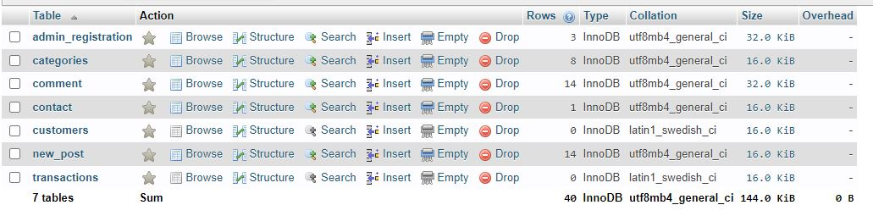

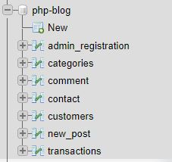

**Project Screenshots**

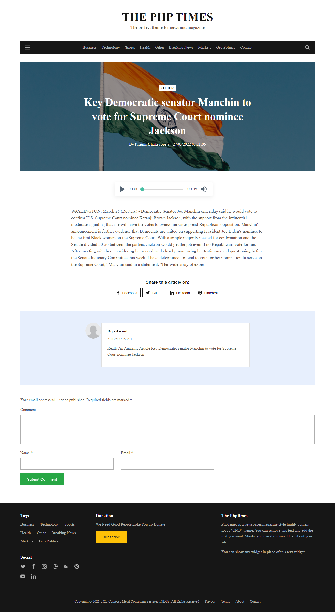



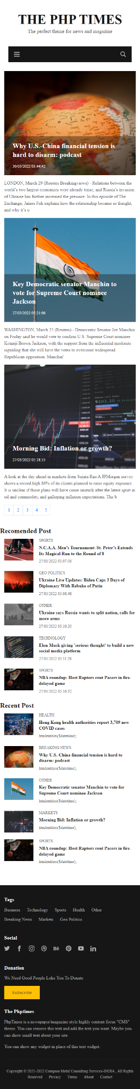

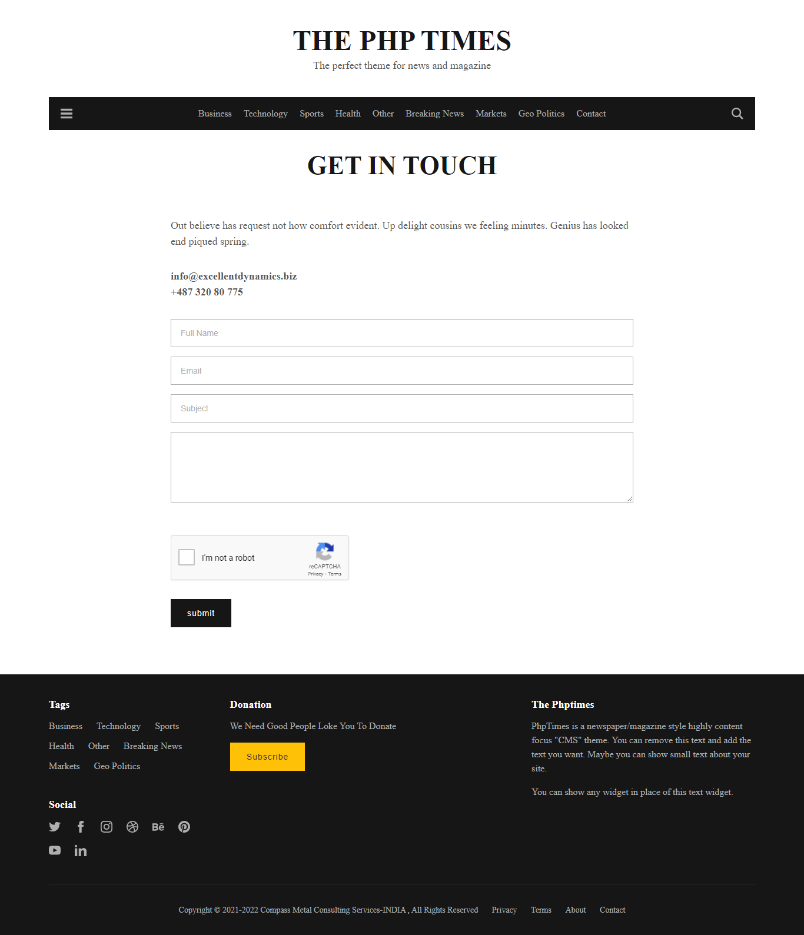



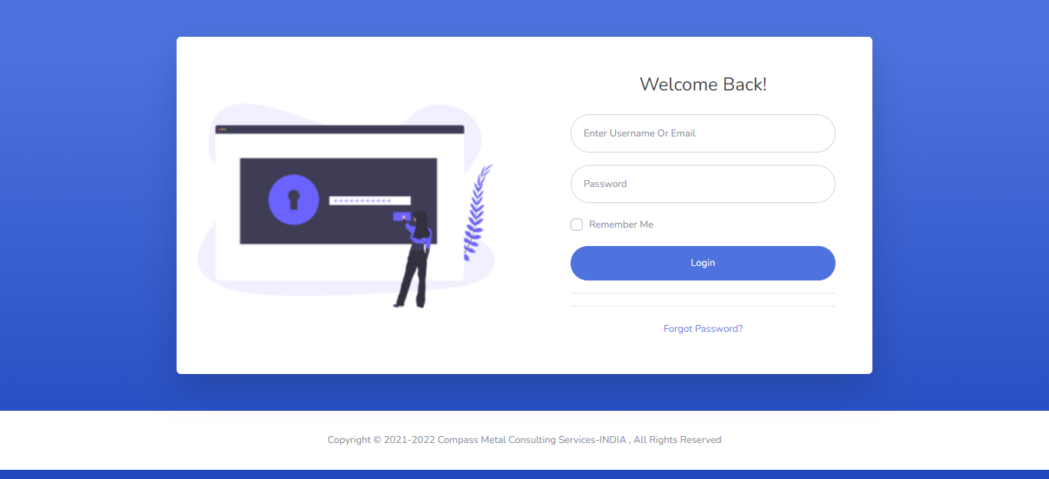

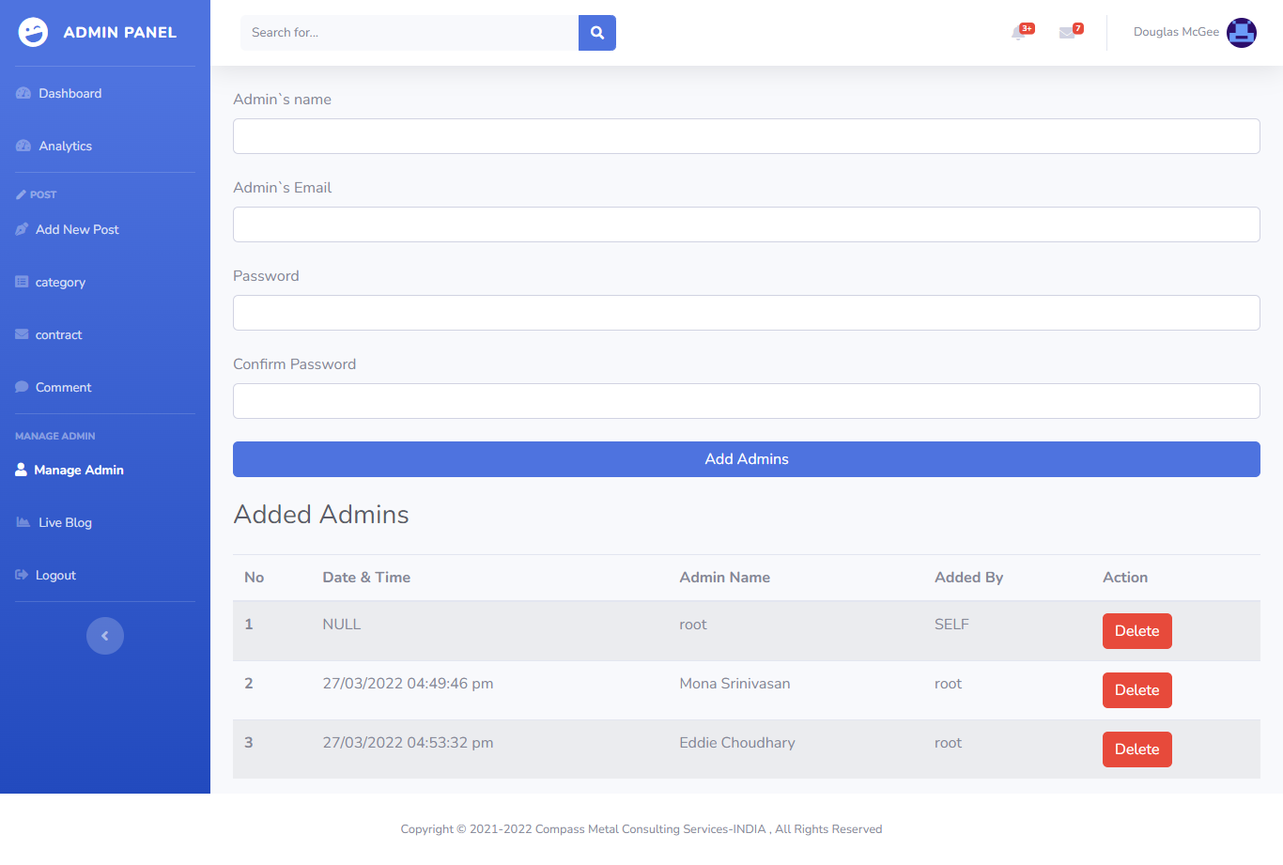

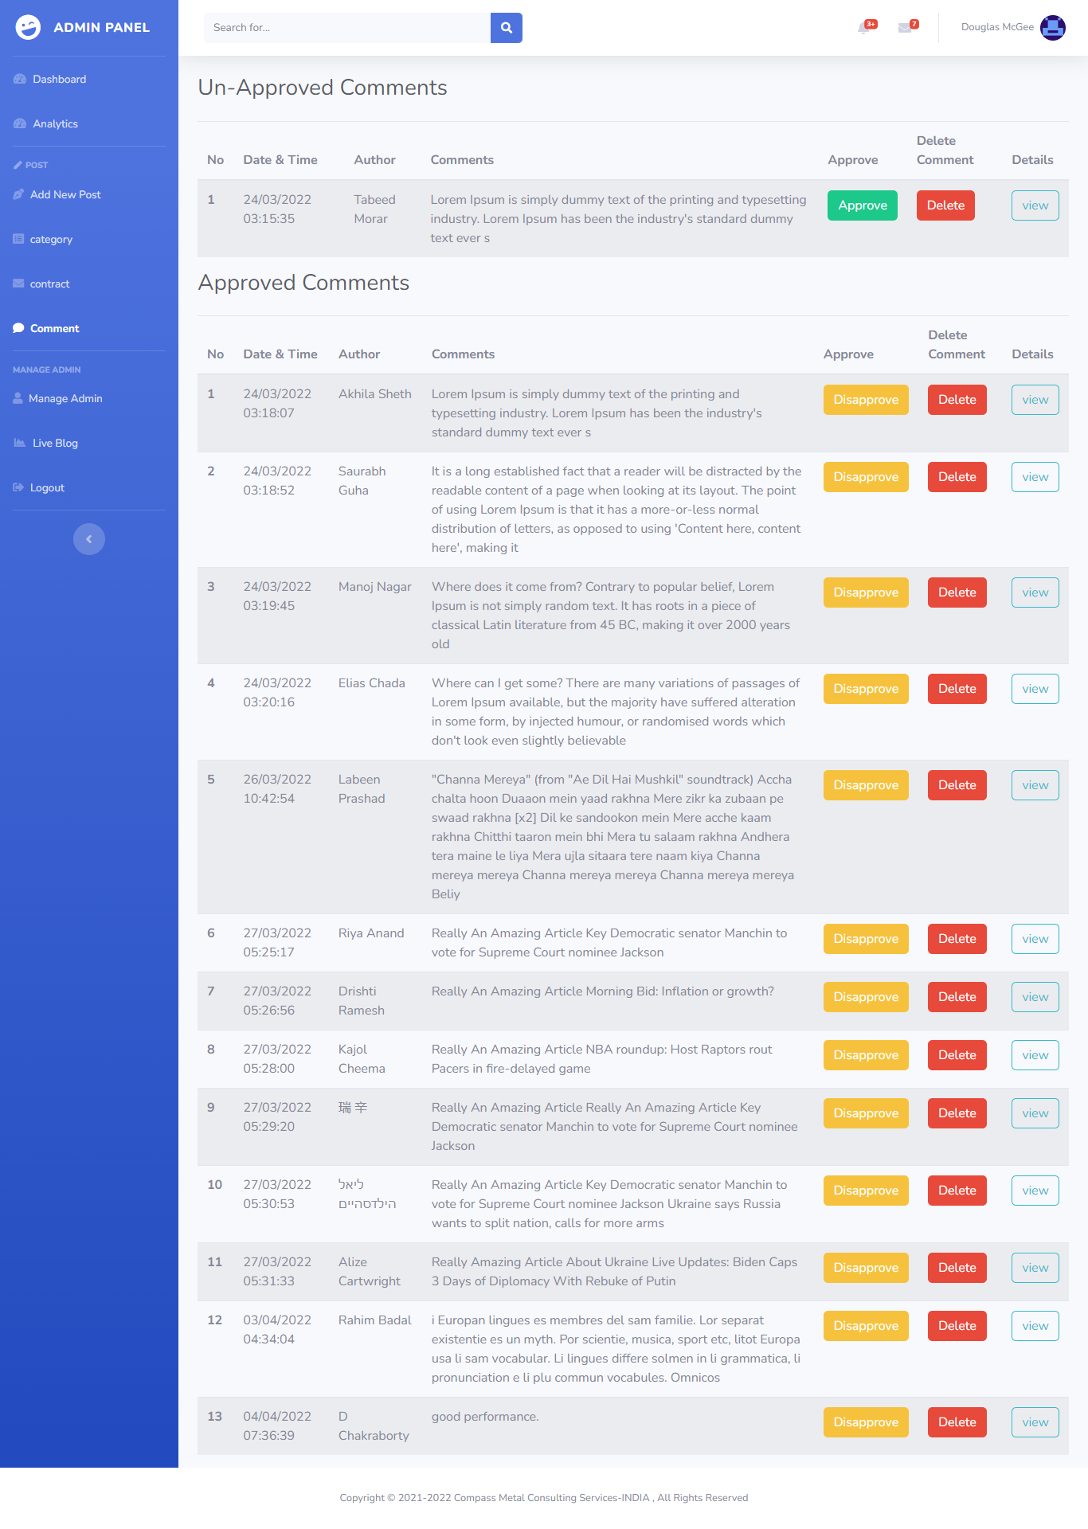

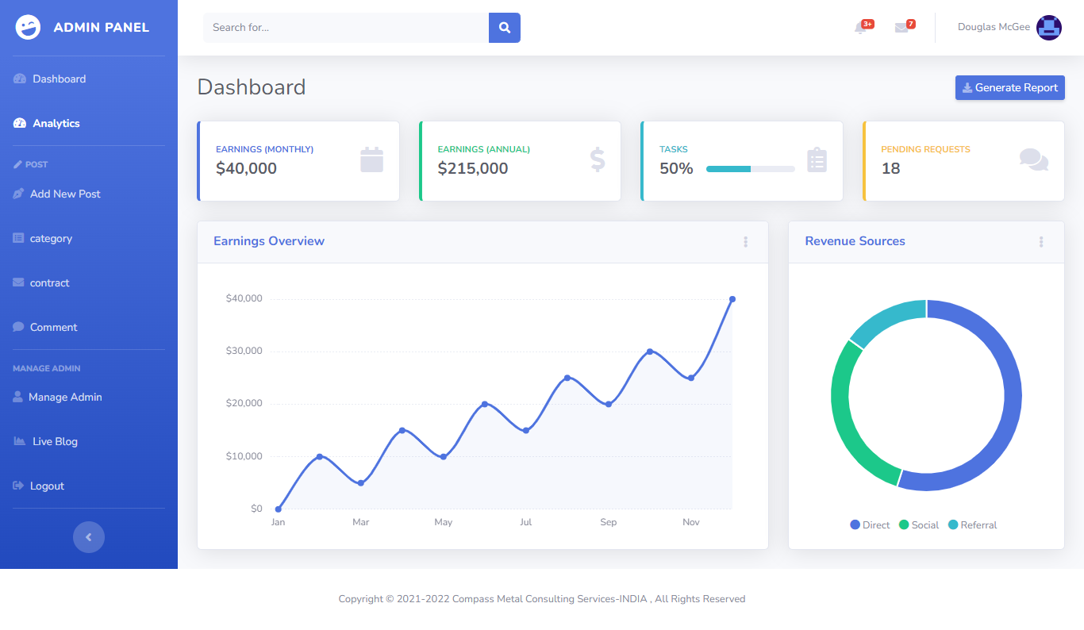Analytics

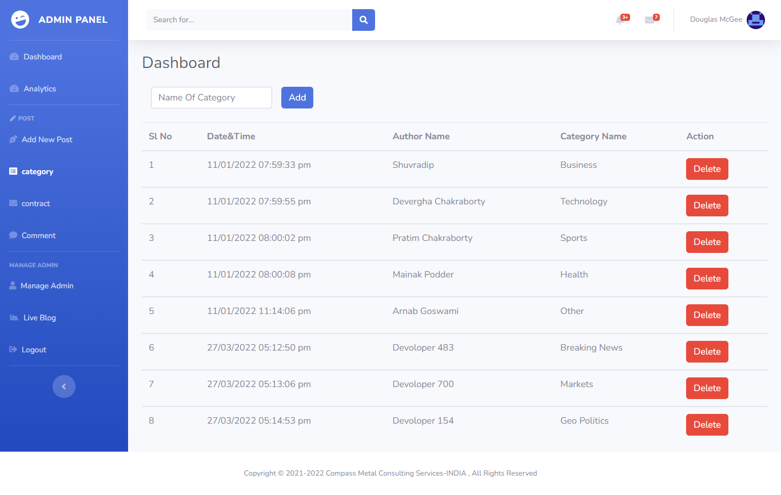Categories

Contact Page

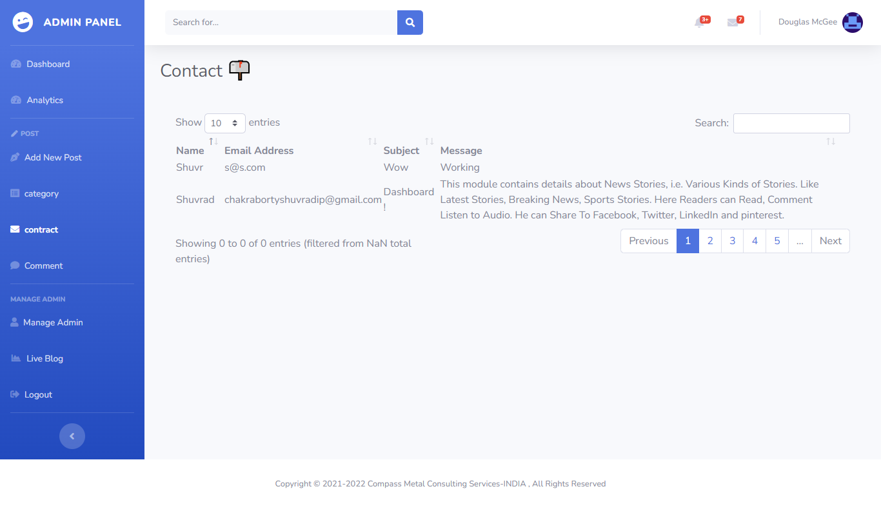

Dashboard

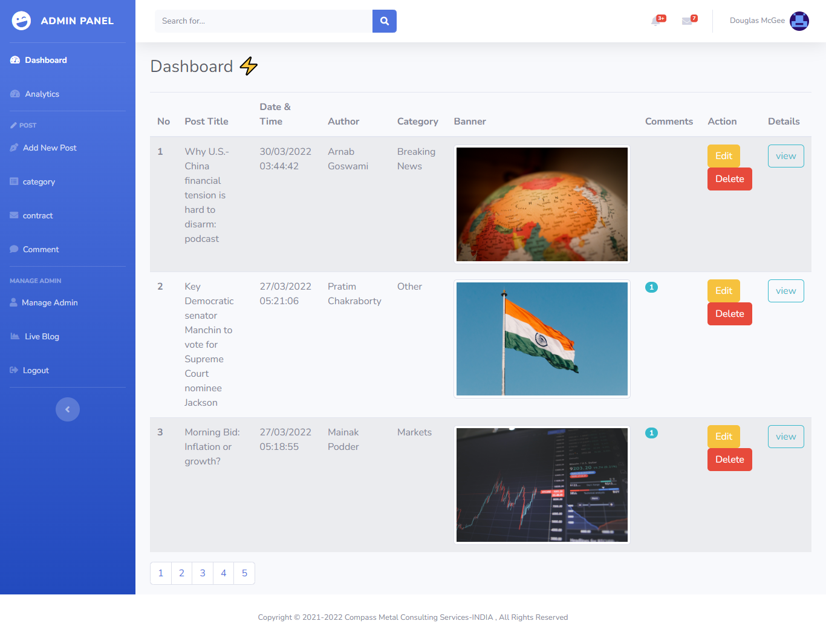

Add New Post Page

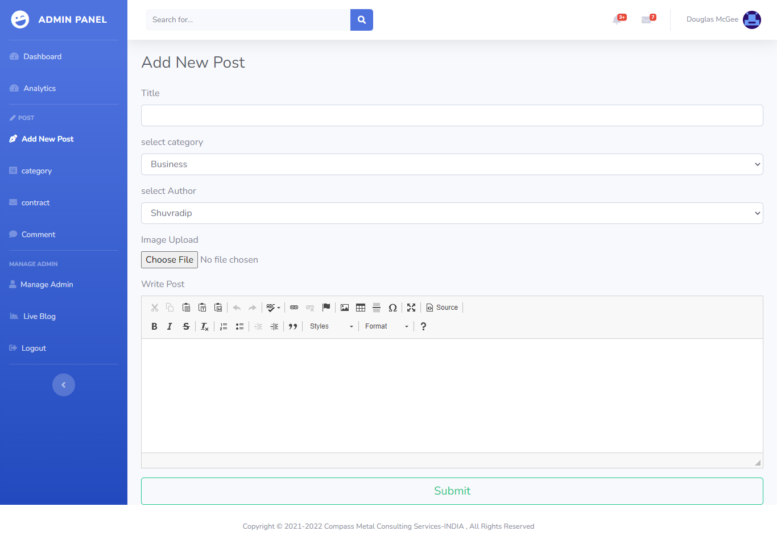

**CONCLUSION AND ENHANCEMENTS**

* 1. **Conclusion**

This system has been developed successfully incorporate all the requirements. Appropriate care has taken during database design maintain database integrity and to avoid redundancy of data. This site was developed in such a way that any further modifications needed can be easily done. User feels freely while using this site. In this all technical complexities are hidden. This site is a more user friendly.

The quality focuses like correctness, efficiency, usability, maintainability, portability, accuracy, errors, tolerance, expandability and communicatively all are successfully done.

### Foreseeable enhancements

There is always a room for improvement in any software package, however good and efficient it may be. The important thing is that the website should be flexible enough for further modifications. Considering this important factor, the web site is designed in such a way that the provisions are given for further enhancements. At present this website provides all the information using forms.

In future we can enhance our project by providing options like. Include many sites information.

**BIBLIOGRAPHY**

### JAVA SERVLETS

**-** TATA McGraw HILL

### SOFTWARE ENGINEERING

- McGraw-Hill Publications

**[J2EE-Overview]** - <http://java.sun.com/j2ee/overview.html>

### [JS-NET] -

<http://developer.netscape.com/docs/manuals/communicator/jsref/contents.htm>

**[J2EE-Home]** - <http://java.sun.com/j2ee/>

**[J2EE-Components]** - <http://java.sun.com/j2ee/blueprints/platform_technologies/component/index.html>

**[SUN-Developer]** - <http://developer.java.sun.com/developer/>